CAPACITY, MANAGEMENT, OPERATION

AND

MAINTENANCE PLAN

(CMOM)

PREPARED

FOR

THE CITY OF SMALL TOWN, MISSOURI

TABLE OF CONTENTS

- Introduction……………………………………………………………………. 1
2.0 Goals.…………………………………………………………………………... 2
3.0 Collection System Management.………………………………………………. 3
3.1 Organization and System Parameters.................................................................. 3
3.11 System Profile....………………………………………………. 3
3.12 Critical Components….………………………………………... 4
3.13 Organizational Structure...……………………………………... 6
3.2 Training……….………………………………………………………………... 7
3.3 Legal Authority………………………………………………………………… 8
4.0 Collection System Inspection and Maintenance Program……………………… 9
4.1 Inspection Component…………………………………………………………. 8
4.11 Sewer Line and Manhole Inspection Schedule………………..... 9
4.12 Lift Station Inspection Schedule………………………………. 10
4.13 Inspections in Response to Complaints………………………… 10
4.2 Maintenance Component……………………………………………………… 10
4.21 Preventative Maintenance……………………………………... 10
4.22 Corrective Maintenance………………………………………... 11
4.23 Emergency Maintenance………………………………………. 11
4.3 Sewer Complaints……………………………………………………………… 11
5.0 I&I Assessment and Reduction Program......………………………………….. 12
5.1 Mapping………………………………………………………………………… 12
5.2 Capacity Determinations……………………………………………………. 12 5.3 Inspection of the Collection System……………………………………………... 13
5.31 Visual………………………………………………………… 13
5.32 Smoke Testing……………………………………………………… 13
5.33 Closed Circuit Television……………………………………………14
5.4 Repairs and Replacement……………………………………………………… 14
5.5 Progress and Reporting………………………………………………………… 14
6.0 Sanitary Sewer Overflow (SSO)/ Bypass Tracking Program.………………..... 15
7.0 SSO/ Bypass Reporting Program..……………………………………… 16
8.0 Capital Improvements Program (Short Term/Long Term Projects and Budget) 17
8.1 Purpose……………………………………………………………………………17
8.2 Development…………………………………………………………………….. 17
8.3 Projects……………………………………………………………………… 17
9.0 Appendices………………………………………………………………………..19
Appendix 9.1: Collection System Map
Appendix 9.2: Ordinances
Appendix 9.3: Manhole Inspection Worksheet
Appendix 9.4: Manhole Inspection Comments
Appendix 9.5: Lift Station Inspection Worksheet
Appendix 9.6: Sewer Line Maintenance Repair Report
Appendix 9.7: Sewer Complaint Report
Appendix 9.8: Sewer Response Report
Appendix 9.9: Tracking Form for SSO/ Bypasses
Appendix 9.10: Self-Reporting Form for SSOs or WWTF Bypasses
Appendix 9.11: Capital Improvement Budget
Appendix 9.12: Capital Improvement Projects

- INTRODUCTION

Sanitary sewer collection systems have a finite capacity to carry wastewater based on the size of the system components. The size of the components is based upon an analysis of the contributory flows into the system, plus a factor for growth. The analysis considers residential, commercial and industrial sources of flow plus a designed leakage rate for the system components. With time, the design basis for the system may change resulting in flows in excess of the designed flow. These factors can lead to sanitary sewer overflows (SSOs) of the sewer collection system as the increased flows exceed the ability of the collection system or lift stations to convey the wastewater to the wastewater treatment facility. SSOs are overflows, spills, diversions, or release of wastewater from a sewer collection system including those that discharge to waters of the state or to public or private property. A SSO can be caused by poor operation and maintenance of the sewer collection system, pipe or equipment failures, increased growth in the community, undersized pumps, aging infrastructure, and most common; excessive inflow and infiltration (I&I). I&I can also route additional water to the wastewater treatment facility, resulting in hydraulic overloading, which could result in a bypass. Operation and maintenance costs will also increase due to more frequent wear and tear on equipment and additional electrical cost as a result of I&I.

SSOs and bypasses, regardless of the cause, can release untreated sewage to surface waters, at times leading to substantial negative impacts by adding excessive nutrients, sediment, pathogens, metals, and organic enrichment to the receiving stream. These impairments can result in the beneficial loss use of a particular stream, even causing acute impact, such as, a fish kill.

2.0 GOALS

The city of [ insert name ] has developed this Capacity, Management, Operation and Maintenance (CMOM) Plan to put into place the ideas, concepts and procedures to be used to prevent SSOs and bypasses at the treatment facility to the extent possible and practicable. The city has utilized the U. S. Environmental Protection Agency’s (EPA) “Guide for Evaluating CMOM Programs at Sanitary Sewer Collection Systems” (Document No. EPA 305-B-05-02) as a basis for developing this document. This document can be found at www.epa.gov/npdes/pubs/cmom_guide_for_collection_systems.pdf

Note: The CMOM is a working document and may need to be modified throughout the calendar year. At a minimum, the city will conduct an [annual] review and modify schedules and procedures in the CMOM to accomplish the goals of the plan.

The goals of the plan are to:

- Prevent overflows from the sanitary sewer and bypasses to the extent possible and practicable
- Manage the assets of the [ utility name ] inclusive of personnel and equipment to affect a regular maintenance program and to be able to respond to emergency overflows and bypasses of the system
- Through the use of analytical and engineering methods, assess and prioritize maintenance, rehabilitation and replacement activities for the portions of the collection system under operational control of the [utility name]
- Decrease budget costs in the long term by reducing the number of equipment failures, repairs and replacement of infrastructure, and general unscheduled or emergency activities associated with the wastewater collection and treatment system
- Through effective management, develop, educate, and enforce when appropriate, ordinances that will help to better manage the performance of the collection system
- Through an effective Capital Improvement Program, establish specific budgeting goals in order to ensure the city is prepared financially to address all of the needs and requirements of the CMOM
3.0 COLLECTION SYSTEM MANAGEMENT

Management of the [insert system name] will be a proactive endeavor so that we are able to meet the goals of this plan as well as to provide our customers with fiscally, technically and environmentally sound operations of the system. An overview of our system along with our management approach is contained in the following sections.

3.1 Organization and System Parameters

3.11 System Profile

The [insert system name] sanitary sewer system consists of gravity and forced main components serving the communities of [insert community names]. The system [is/is not] interconnected with other sanitary collection systems. [If interconnected, indicate name of systems interconnected with, points of interconnection, average and peak flows, and legal arrangements]. Maps of the system are maintained by the utility at [insert location].

Note: See also Appendix 9.1 for a copy of the city’s map(s).

The system profile is as follows:

City of [insert name] System Profile
Total Population Served
Population of Primary Community* - [insert name]
Population of Interconnected Communities
Size of Service Area (acres)
Total Customers
Treatment Plant Name(s) and Description of
Treatment Process
Plant Design Capacity
Average Daily Wastewater Flow at the treatment plant
Average Hourly Peak Wastewater Flow at the treatment plant
Miles of PVC and other plastic gravity sewers
Miles of vitrified clay gravity sewers
Miles of cast iron gravity sewers
Miles of ductile iron gravity sewers
Miles of brick gravity sewers
Miles of concrete gravity sewers
Miles of steel gravity sewers
Miles of gravity sewers (other – insert type)
Total miles of Gravity Sewers
Miles of HDPE force mains
Miles of PVC and other plastic force mains
Miles of cast iron force mains
Miles of ductile iron force mains
Miles of steel, cement lined force mains
Miles of concrete force mains
Miles of brick force mains
Miles of force main (other – insert type)
Total miles of Force Mains
Age of System (collection system & treatment plant)
Number of Pump Stations
Number of Pump Station w/Backup Power
Number of Inverted Siphons
Number of Manholes
Number of Air Relief Valves
Number of Employees

* Community responsible for this specific plan

  - Critical Components

In this section, critical components of the [insert system name] will be identified and described. This information will be used later under Section 4.0 Collection System Inspection and Maintenance Program and Section 5.0 I&I Assessment and Reduction Program. The components of the collection system that are critical in terms of conditions include lines with frequent backups, lines buried underneath flowing streams, lines in isolated areas where overflow detection would be unlikely, facilities without backup power, parts of the system where root intrusion is reoccurring, old components, non-redundant components, and components or facilities known by the system to be critical (example; lift stations, manhole, etc.).

In addition, we will calculate the average dry weather flows versus wet weather flows for the most recent 12-month period. The total number of SSOs that have occurred in that same time period will also be documented. A facility is considered to have significant sources of I&I when wet weather flows are equal to or greater than 2.5 times the dry weather flows. Four or more SSOs per 100 miles of sewer pipe also indicate problems associated with the collection system.

Note: Evaluation of whether or not a sanitary sewer collection system is experiencing wet weather flows greater than or equal to 2.5 times normal dry weather flow will be determined using the following method. The monthly average dry weather flow rate will be compared to the maximum day effluent flow, if the maximum day can be assumed to be a wet weather event.

$\frac{\sum{\text{Daily} \text{Dry} \text{Weather} \text{Flow} \left(\text{one} \text{month}\right)}}{ \text{of} \text{Days}} = \text{Average} \text{Dry} \text{Weather} \text{Flow} \left(\text{GPD}\right)$

$\frac{\text{Maximum} \text{Day} \text{Flow} \left(\text{GPD}\right)}{\text{Average} \text{Dry} \text{Weather} \text{Flow} \left(\text{GPD}\right)} = \text{Wet} \text{Weather} \text{Flow} \text{Factor}$

IF, Wet Weather Flow Factor > 2.5,

THEN, The system is considered to have significant sources of I&I.

This calculation will be considered for all wet weather months. If the Wet Weather Flow Factor is usually greater than 2.5 for the maximum day effluent flow for any given month, then I&I is a significant problem and the sources of I&I will be located. See Section 5.0, I&I Assessment and Reduction Program. By using this method, our system can take an average of the Wet Weather Flow Factors for 12 months, and get an average Wet Weather Flow Factor for any given year. This is a good method to use when evaluating several years of flow data to determine historical trends in the collection system.
  - Critical Components

A description of the [insert system name] critical components are listed below

3.13 Organizational Structure

A description of the city of [insert name] organizational structure, including the positions responsible for implementing the elements of this CMOM plan and lines of authority are listed in the following paragraphs. Included in the description are the number of employees inclusive of management, operations, administrative, and emergency response personnel. This section clearly depicts those positions in the chain of command; including who is responsible for maintenance, operations, asset management, maintenance scheduling, equipment replacement decisions, and responding to environmental emergencies.

3.2 Training

Each employee is required to obtain professional/trades development training each year upon approval by an immediate supervisor. Training may be in the form of formal off-site or on-site training, on-the-job training, college or vocational course work or other appropriate venue. The training will be directly relevant to the employee’s duties as described in his or her job description. If an employee is required to obtain continuing education units (CEUs) for his or her operator certification, the employee is required to determine if the certificate granting agency will provide CEUs before the employee begins the course.

Required Training

Within the first year of employment, each employee will attend a course in lock out/tag out and confined space entry. The utilities superintendent or designee will approve the course prior to attendance.

Other potential course topical areas include:
- Routine line maintenance including rodding, cabling, chemical and jet cleaning
- Traffic control
- Environmental andsafety regulations
- Pump stations operation and maintenance
- Laboratory procedures, equipment calibration, sample collection and handling
- Electrical and instrumentation
- Sewer overflow response and reporting
- Collection system evaluation including smoke testing and closed circuit television
- Pipe repair
- Collection system rehabilitation including pipe bursting, cured in place, slip lining, and trenching/shoring
- Wastewater System Operations and Maintenance

3.3 Legal Authority

A summarized description of the city of [insert name] utility’s ordinance(s), service agreements, etc., providing legal authority to control the elements of an EPA CMOM program are outlined below. The elements addressed include the following: 1) I&I; 2) Sewer design, installation, testing and inspection standards; 3) Controlling flow from satellite systems; 4) Utility access to all system locations; 5) Pretreatment program, if necessary; and 6) Sewer and grease ordinance, to include grease traps, 6) Private service laterals and illegal storm water connections.

Note: See Appendix 9.2 for a copy of the city’s utility ordinance(s).

4.0 COLLECTION SYSTEM INSPECTION AND MAINTENANCE PROGRAM

The [insert system name] is a foundational component of the city’s infrastructure; providing a necessary service to the citizens. As such, it is important that the city have a well-planned, systematic, and comprehensive Collection System Inspection and Maintenance Program (Program). Such a program will help ensure service and reliability are maximized at minimal costs and help ensure the sustainability of the collection system. An effective program will increase maintenance activities. Thus, corrective maintenance and emergency maintenance in response to imminent or occurring sanitary sewer overflows are reduced, saving time and money.

4.1 Inspection Component

The program has a schedule that ensures the entire collection system is inspected every [ten years or less]. Inspection of the collection system includes smoke testing, dyed water injection, or closed-circuit television inspections of the sewer lines, as well as inspections of all the manholes and lift stations.

4.11 Sewer Line and Manhole Inspection Schedule

The city has been divided into [number] [sections/watersheds], as seen in Table 4.1 and Appendix 9.1 Collection System Map, through which inspection activities for the sewer lines and manholes will continuously rotate. Additionally, each manhole has been given a unique, permanent number. Findings of the inspection activities within a [section/watershed] will provide the basis for a majority of the scheduled maintenance within that [section/watershed] the following year.

Program Year | Section/Watershed | Miles/Feet of Gravity Sewer Line | Pipe Material | Manholes | Total Number of Manholes | First Rotation Calendar Year
Example | City Creek Watershed | 2,000 ft.  5,000 ft.  1,500 ft. | Clay  PVC  DIP | #001 - #010  #010A - #023 | Brick  Concrete | 2010
 | (add rows as appropriate for City)

Table 4.1 Sewer Line and Manhole Inspection Schedule

A. Each manhole within the [section/watershed] for the given program year will be inspected during dry weather and wet weather, and the Manhole Inspection Worksheet and Comments form will be filled out (Appendices 9.3 and 9.4).
B. Smoke testing and dyed water injection will be conducted throughout the [section/watershed] initially.
C. Based on the findings, areas of sewer lines will be scheduled for further closed-circuit television inspections or repairs and rehabilitation. Locations where there is direct stormwater connection to the sewer collection system will be addressed through the city’s ordinance enforcement procedures.

4.12 Lift Station Inspection Schedule

Each lift station in the city’s sewer collection system will be inspected [daily] for its general condition. Each lift station will be drained and thoroughly inspected [annually] according to Table 4.2. The Lift Station Inspection Worksheet (Appendix 9.5) will be completed during normal regularly scheduled inspections.

Lift Station | Lift Station Type | Capacity | Month
Example, City Center LS | Duplex, submersible | gpm, total flow, etc. | January
(add rows as appropriate for City)

Table 4.2 Lift Station Annual Inspection Schedule

4.13 Inspections in Response to Complaints

In addition to the regularly scheduled inspections listed in Tables 4.1 and 4.2, time must be allowed for inspections of the collection system initiated by citizen complaints. Complaint inspections will follow any necessary maintenance or cleaning activity conducted in response to the complaint. Inspection worksheets will be completed as appropriate. Please refer to Section 4.3, Sewer Complaints, for further instructions on complaint response.

4.2 Maintenance Component

The program classifies maintenance activities as: Preventative, Corrective, and Emergency. All repairs and maintenance work will be included in the Capital Improvements Plan (Section 8.0). The activities completed will be tracked and records maintained.

4.21 Preventative Maintenance

Preventative maintenance will be scheduled according to the equipment manufacturer and the needs of the city, based on how critical the equipment is to proper system functions (manufacturers’ recommendations or city preference, whichever is more conservative).

Equipment | Location | Manufacturer | Maintenance Activity | Schedule
Example, duplex pumps | City Center LS |  | Check amperage and voltage | Weekly
Sewer Jet Machine | City Street Dept. |  | Oil, filter, lube
(add rows as appropriate for city)

Table 4.3 Preventative Maintenance Schedule

4.22 Corrective Maintenance

The majority of the maintenance activities (e.g., sewer jetting, root cutting, etc.) are scheduled according to the findings of the inspection activities within a [section/watershed]. Scheduling of maintenance activities will be done through the city’s work order process. Corrective maintenance may be scheduled immediately after inspection activities reveal an imminent problem that must be corrected to avoid an emergency situation. The completed work will be reported on the Sewer Line Maintenance Repair Report (Appendix 9.6).

4.23 Emergency Maintenance

Emergency maintenance cannot be scheduled, but a procedure for responding to and remediating the emergency situation must be developed. The completed work will be reported on the Sewer Line Maintenance Repair Report (Appendix 9.6).

4.3 Sewer Complaints

Information received from a citizen reporting a sewer complaint must be recorded on the Sewer Complaint Report (Appendix 9.7). All information listed on the form will be collected by the city staff person taking the complaint. The form is available on the [Computer file location and/or appropriate hard file location at City Hall or treatment plant].

Response to a sewer complaint may require that immediate corrective or emergency maintenance be conducted to correct the situation. If such maintenance is conducted, the Sewer Line Maintenance Repair Report (Appendix 9.6) will be completed.

The location of every complaint received by the city will be inspected after any necessary maintenance activities are completed to alleviate the complaint situation. Inspections will be conducted as appropriate for the location. In addition to the inspection worksheets, the Sewer Response Report (Appendix 9.8) will be completed.

- I&I ASSESSMENT AND REDUCTION PROGRAM

Inflow and infiltration (I&I) are terms used to describe the ways groundwater and stormwater enter the sanitary sewer system. Inflow is water that enters the sewer system through improper connections, such as downspouts, broken piping at creek crossings, and groundwater sump pumps. Infiltration is groundwater that enters the sewer system through breaks in the piping. All of this water is often called “clear water” to distinguish from sanitary sewage. Clear water belongs in storm sewers or on the surface of the ground and not in the sanitary sewers. When clear water gets into the sanitary sewers, it must be moved and treated like sanitary waste. Too much clear water often causes sewer backups and sanitary sewer overflows (SSOs) when it rains. Excessive I&I is one of the leading causes of SSOs and one of the most labor intensive and expensive problems to correct. Failing to correct or reduce I&I leads to basement backups, SSOs and bypasses at the treatment plant. Overflow occurrences put public health at risk and violate state and federal environmental regulations as well as increased costs at the wastewater treatment plant. Additionally, sewer backups into basements or households can result in litigation and potential liabilities for the city. By reducing I&I, the city can reduce operating costs and increase the lifetime capacity of the lift stations and treatment plant as well as maintain compliance with state and federal water quality regulations.

5.1 Mapping

The first step in the process of locating and repairing sources of I&I is to ensure an accurate map of the collection system is available. The map will be used to identify manholes, lift stations, and service main locations. In the event that an accurate map is not available, the city will have GPS coordinates of the collection system. Using an accurate map, the city will divide the collection system into designated areas that will be prioritized based on known problem areas with a schedule to inspect the lines in a designated area. Sewer lines that were installed within the last 15 years may be excluded from the plan unless there is a reason to believe they are a major source of I&I. The city is proposing to update its collection system maps during fiscal year [2010]. This project will be incorporated as part of the city’s capital improvement projects. See Appendix 9.12.

5.2 Capacity Determinations

The concept of capacity for a wastewater system has two basic elements; the capacity of the wastewater plant and the capacity of the collection system. Inflow/infiltration and growth can result in wastewater flows exceeding the design capacity of either the plant or collection system or both. Capacities within the collection system vary by the size of the piping making up the system. It is desirable to determine capacities within the collection system to gauge whether portions are subject to surcharging and overflows and to develop a baseline from which planning decisions regarding new connections may be made.

Even if the treatment plant flows are within the design capacity, portions of the collection system could be receiving flows in excess of their design capacities. There are a number of simple ways to determine if the collection system is receiving excess flows. Where this condition is suspected or verified, more specific evaluation methods are to be used to determine the exact flows. The [insert system name] will make an initial assessment of collection system capacity via the following methodology. The city will monitor the lift station hour meter readings on a daily basis and calculate pumping rates (Pump Run Time multiplied by GPM Rating For Each Pump) to determine capacity issues and record the information on the Lift Station Worksheet (Appendix 9.5). Pumping rates will be monitored and compared during both dry and wet weather conditions. Daily rainfall will be recorded on the city’s monthly discharge monitoring reports. In portions of the collection system in which I&I or capacity issues are known or suspected, flow monitoring within the collection system at appropriate locations will be conducted in conjunction with corrective measures. The frequency and location of monitoring shall be determined by the city on a case-by-case basis but will be sufficient enough to be representative of seasonal average and peak flows and sufficient to indicate if corrective measures are effective. A comprehensive evaluation of the system’s capacity will be made during fiscal year [2010] and incorporated as part of the city’s capital improvement projects. See Appendix 9.12.

5.3 Inspection of the Collection System

5.31 Visual

Using the map of the collection system, the city will conduct visual inspections of all manholes and lift station locations during fiscal year(s) [2010-2011]. See Appendix 9.12, Capital Improvement Projects. Each manhole and lift station will be identified and inspected to obtain general information concerning the condition of each structure. Elements to be inspected include depth, construction material, depth of flow, surcharge conditions or noted high water marks, visible leakage, and need to repair. All findings will be documented accordingly using the forms and worksheets found in Appendices 9.3- 9.6. The city will also track and investigate citizen’s complaints using the Sewer Complaint and Response Report Worksheets (Appendices 9.7 and 9.8).

5.32 Smoke Testing

The city will conduct smoke testing on the collection system beginning with those sections suspect of inflow based on the flow studies performed in Section 5.2 and the visual inspections outlined in Section 5.31. Smoke testing will be conducted during dry conditions. Notification to property owners will be made prior to beginning the smoke testing since smoke can enter homes through illegal connections. Property owners will be required to immediately correct illegal connections consistent with the city of [insert name] ordinance banning storm and groundwater connections to the sanitary sewer.

In the event storm sewers are found to be connected into the sanitary sewer where a separate storm sewer exists, the city will make repairs to reconnect to the storm sewer system. All sources of inflow will be documented and keyed on the collection system map. Smoke testing of the collection system will be performed during fiscal year(s) [2010-2011]. See Appendix 9.12, Capital Improvement Projects.

5.33 Closed-Circuit Television (CCTV)

In the case of suspected excess infiltration, the [insert system name] will conduct closed-circuit television surveillance of the portions of the collection system believed to be impacted by groundwater infiltration. The surveillance will be conducted during wet conditions and sources of infiltration will be documented and keyed on the collection system map. A schedule for performing CCTV surveillance has been noted in Appendix 9.12, Capital Improvement Projects.

5.4 Repairs and Replacement

Based upon findings from inspections of the collection system, repairs and replacements will be prioritized by severity and corrected in phases. Emergencies that are contributing to significant SSOs will be corrected immediately. All repairs will be included in the city’s capital improvements program. See Appendix 9.12.

In the case of illegal service connections, such as, stormwater guttering and sump pumps, the city will work with its customers through its sewer use ordinance to ensure these connections are properly disconnected in a timely manner.

5.5 Progress and Reporting

The city utility superintendent will prepare quarterly evaluation reports for the city manager and/or mayor and city council documenting progress made towards reducing I&I. These reports will also serve as a basis for planning and budgeting future I&I projects that will be captured in the city’s ongoing capital improvement program (See Appendices 9.11 and 9.12). In addition, progress reports will be forwarded to the Department of Natural Resources according to the requirements outlined in the city’s NPDES permit.

6.0 SANITARY SEWER OVERFLOW (SSO)/ BYPASS TRACKING PROGRAM

The [insert system name] tracking and management system will include all information necessary to establish a system that is effective and collect useful information for SSOs, bypasses, backup events, and responses to such events. The tracking and management system will also be designed and operated in a manner that allows the city to use the system for operation and maintenance activities, long term management of the wastewater treatment system and operations of the I&I Assessment and Reduction Program. The city’s tracking system will be managed in an electronic database and will include the following information
(at a minimum):

- Date and time (best estimate) of the event
- Precipitation data (including intensity and duration)
- Source of the information (e.g. citizen complaint, observation)
- Location of the SSO, bypass or backup
- Duration of the discharge (estimate or monitored)
- Best estimate of the volume discharged, including flow metering data where applicable
- Sampling results from any sampling performed
- Identification of the water body to which the wastewater was released
- Cause of the discharge
- Measures taken to respond to the discharge
- Date and time of repairs
- Measures taken to prevent reoccurrence
- Date and time notification to Department of Natural Resources regional office

Note: See Appendix 9.9 for a copy of the City’s tracking form.
- SSO/ BYPASS REPORTING PROGRAM

The city of [insert name] Missouri State Operating Permit [MO-#######] Standard Conditions Part I Sections B 2 and 5; and Missouri Department of Natural Resources Regulation 10 CSR 20-7.015 (9) (E) 2 require the city to report all SSOs and bypasses to the Missouri Department of Natural Resources within 24 hours and follow up with a written report within five days unless waived by the department.

The city will contact the Department of Natural Resources, [insert the name of regional office] at [insert phone number] within 24 hours of the permittee becoming aware of an SSO or bypass. If the SSO or bypass occurs after normal business hours or on the weekend, the city will contact the department of Natural Resources Emergency Spill Line at 573-634-2436.

A written response will be submitted to the [insert the name of the regional office] Regional Office within five business days or time agreed to by the regional office using the department’s “Self-Reporting Form for Sanitary Sewer Overflows or Wastewater Treatment Facility Bypasses.” A record of each occurrence will also be entered into the city’s electronic tracking database.

Note: See Appendix 9.10 for a copy of the Department of Natural Resources Self-Reporting Form for Sanitary Sewer Overflows or Wastewater Treatment Facility Bypasses.

8.0 CAPITAL IMPROVEMENTS PROGRAM
(SHORT TERM/LONG TERM PROJECTS and Budget)

  - Purpose

When setting short term and long term goals for sanitary sewer system repairs, maintenance and upgrade, it is crucial to have a capital improvements program (CIP) in place to make certain that the available and planned budget parallels those infrastructure goals. The purpose of the city of [insert name] CIP is to set forth specific budgeting goals in order to ensure it is prepared financially to address all of the needs and requirements of the CMOM. The city will make an annual review of its sewer rates and compare them with the operations budget and adjust accordingly to support the CMOM program, along with other cost associated with operating and maintaining the sewer system.

  - Development

The CIP budget will be developed and reviewed on an annual basis as provided in the attached budget worksheet, see Appendix 9.11. This CIP budget is for sanitary sewer work only and will be maintained separate from other city funds. Although the CIP budget may include funds for emergency repairs, the primary goal of the CIP is to address longer term improvements, versus only immediate repairs. As part of the annual CIP budget review, funds will be set aside each year as savings for larger projects or longer term capital improvements. The CIP projects will be organized and prioritized as follows.
- Current Fiscal Year Planned Improvements
- Five-Year Projected Improvement Plan
- Long Term, 5 to 20-Year Projected Improvement Plan

Projects will be prioritized in this project timeline based upon need, state and federal requirements, and available finances. See Appendix 9.12 for a detailed list of the city’s proposed projects.

As part of the annual review of the CIP, the city will also review sewer use rates and compare revenues to the expenditures required by the operations budget and CIP. As appropriate, the city will increase sewer use rates as needed to meet the requirements of the operations budget and CIP.
  - Projects

Projects addressed by the CIP belong to three categories: collection system inspection and maintenance, I&I assessment and reduction, and replacement or upgrade of sanitary sewer or wastewater treatment facility components. Often, these three categories may overlap; however, prioritization of budget for each of these categories will proceed as follows.

Collection system inspection and maintenance includes but is not limited to manhole inspections, pump station inspection and maintenance, inspections at SSO locations, and removal of line blockages. This work is done [daily/weekly], based on a pre-determined schedule, or as needed. The schedule requires regular inspection and maintenance on individual portions of the collection system on a rotating basis.

I&I assessment and reduction projects will proceed as described in the plan outlined in Section 5.0 of this CMOM. The I&I Assessment and Reduction Program will prioritize projects based upon location, flow, number of SSO events, and economic factors. The projects addressed in this plan will be included on both the short term and the long term CIP project lists.

Replacement or upgrades of the collection system or wastewater treatment system components will be prioritized based upon immediate need, determinations made through the I&I Assessment Program, and the requirements of state and federal environmental regulations.

- APPENDICES

Appendix 9.1: Collection System Map
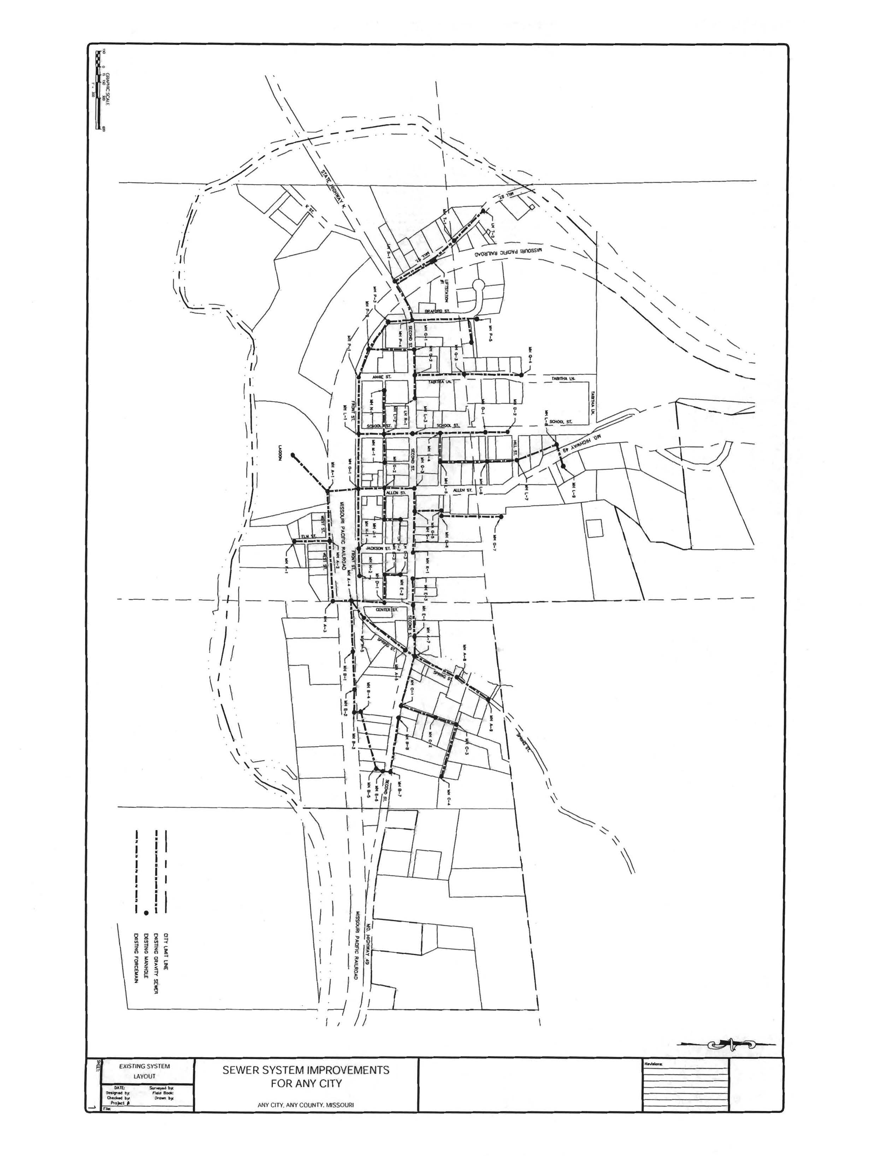
Appendix 9.2: Ordinance(s)

(Ordinance/Resolution) No.

AN ORDINANCE REGULATING THE USE OF PUBLIC AND PRIVATE SEWERS AND DRAINS, PRIVATE SEWAGE DISPOSAL, THE INSTALLATION AND CONNECTION OF BUILDING SEWERS, AND THE DISCHARGE OF WATERS AND WASTES INTO THE PUBLIC SEWER SYSTEM(S): AND PROVIDING PENALTIES FOR VIOLATIONS THEREOF: IN THE (CITY/DISTRICT) OF , COUNTY
OF , STATE OF MISSOURI.
Be it ordained by the (Mayor/Superintendent) and the (Board of Alderman/Board Members), of the (City/District) of , State of Missouri, as follows:
ARTICLE I
Unless the context specifically indicates otherwise, the meaning of terms used in this ordinance shall be as follows:

Section 1: "BOD" (denoting Biochemical Oxygen Demand) shall mean the quantity of oxygen utilized in the biochemical oxidation of organic matter under standard laboratory procedure in five (5) days at 20^{O}C, expressed in milligrams per liter.

Section 2: "Building Drain" shall mean that part of the lowest horizontal piping of a drainage system which receives the discharge from soil, waste, and other drainage pipes inside the walls of the building and conveys it to the inner face of the building wall.

Section 3: "Building Sewer" shall mean the extension from the building drain to the public sewer or other place of disposal.

Section 4: "Combined Sewer" shall mean a sewer receiving both surface runoff and sewage.

Section 5: "Garbage" shall mean solid wastes from the domestic and commercial preparation, cooking and dispensing of food, and from the handling, storage and sale of produce.

Section 6: "Industrial Wastes" shall mean the liquid wastes from industrial manufacturing processes, trade, or business as distinct from sanitary sewage.

Section 7: "Natural Outlet" shall mean any outlet into a watercourse, pond, ditch, lake or other body of surface or groundwater.

Section 8: "Person" shall mean any individual, firm, company, association, society, corporation, or group.

Section 9: "pH" shall mean the logarithm of the reciprocal of the weight of hydrogen ions in grams per liter of solution.

Section 10: "Properly Shredded Garbage" shall mean the wastes from the preparation, cooking and dispensing of food that have been shredded to such a degree that all particles will be carried freely under the flow conditions normally prevailing in public sewers, with no particle greater than one-half (1/2) inch (1.27 centimeters) in any dimension.

Section 11: "Public Sewer" shall mean a sewer in which all owners of abutting properties have equal rights, and is controlled by public authority.

Section 12: "Sanitary Sewer" shall mean a sewer which carries sewage and to which storm, surface and groundwaters are not intentionally admitted.

Section 13: "Sewage" shall mean a combination of the water-carried wastes from residences, business buildings, institutions, and industrial establishments, together with such ground, surface, and storm waters as may be present.

Section 14: "Sewage Treatment Plant" shall mean any arrangement of devices and structures used for treating sewage.

Section 15: "Sewage Works" shall mean all facilities for collection, pumping, treating and disposing of sewage.

Section 16: "Sewer" shall mean a pipe or conduit for carrying sewage.

Section 17: "Shall" is mandatory; "May" is permissive

Section 18: "Slug" shall mean any discharge of water, sewage, or industrial waste which in concentration of any given constituent or in quantity of flow exceeds for any period of duration longer than fifteen (15) minutes more than five (5) times the average twenty-four (24) hour concentration or flows during normal operation.

Section 19: "Storm Drain" (sometimes termed "storm sewer") shall mean a sewer which carries storm and surface waters and drainage, and unpolluted cooling water, but excludes sewage and industrial wastes.

Section 20: "Superintendent" shall mean the Superintendent of Sewage Works and/or Water Pollution Control of the (City/District) of , or his authorized deputy, agent, or representative.

Section 21: "Suspended Solids: shall mean solids that either float on the surface of, or are in suspension in water, sewage, or other liquids, and which are removable by laboratory filtering.

Section 22: "Watercourse" shall mean a channel in which a flow of water occurs, either continuously or intermittently.

Section 23: "Hearing Board" shall mean that Board appointed according to provision or Article (This section to be included only if optional article entitled "Hearing Boards" is made a part of the ordinance.)
ARTICLE II

Section 1: It shall be unlawful for any person to place, deposit, or permit to be deposited in any unsanitary manner on public or private property within the (City/District) of , or in any area under the jurisdiction of said (City/District), any human or animal excrement, garbage, or other objectionable waste.

Section 2: It shall be unlawful to discharge to any natural outlet within the (City/District) of, or in any area under the jurisdiction of said (City/District) of, any sewage or other polluted waters, except where suitable treatment has been provided in accordance with subsequent provisions of this ordinance.

Section 3: Except as hereinafter provided, it shall be unlawful to construct or maintain any privy, privy vault, septic tank, cesspool, or other facility intended or used for the disposal of sewage.

Section 4: The owner of all houses, buildings, or properties used for human employment, recreation, or other purposes, situated within the (City/District) and abutting on any street, alley, or right-of-way in which there is now located or may in the future be located a public sanitary or combined sewer of the(City/District), is hereby required at his expense to install suitable toilet facilities therein, and to connect such facilities directly with the proper public sewer in accordance with the provisions of this ordinance, within sixty (60) days (suggested deadline) after date of official notice to do so, provided that said public sewer is within one hundred (100) feet (30.5 meters) (suggested limit) of the property line.

ARTICLE III

Section 1: Where a public sanitary or combined sewer is not available under the provisions of Article II, Section 4, the building sewer shall be connected to a private sewage disposal system complying with the provisions of this article.

Section 2: Before commencement of construction of a private sewage disposal system the owner shall first obtain a written permit signed by the Superintendent. The application for such permit shall be made on a form furnished by the (City/District), which the applicant shall supplement by any plans, specifications, and other information as are deemed necessary by the Superintendent. A permit and inspection fee of $ shall be paid to the (City/District) at the time the application is filed.

Section 3: A permit for a private sewage disposal system shall not become effective until the installation is completed to the satisfaction of the Superintendent. He shall be allowed to inspect the work at any stage of construction and, in any event, the applicant for the permit shall notify the Superintendent when the work is ready for final inspection, and before any underground portions are covered. The inspection shall be made within hours of the receipt of notice by the Superintendent.

Section 4: The type, capabilities, location, and layout of a private sewage disposal system shall comply with all recommendations of the Department of Public Health of the State of Missouri. No permit shall be issued for any private sewage disposal system employing subsurface soil absorption facilities where the area of the lot is less than 40,000 square feet. No septic tank or cesspool shall be permitted to discharge to any natural outlet.

Section 5: At such time as a public sewer becomes available to a property served by a private sewage disposal system, as provided in Article II, Section 4, a direct connection shall be made to the public sewer in compliance with this ordinance, and any septic tanks, cesspools, and similar private sewage disposal facilities shall be abandoned and filled with suitable material.

Section 6: The owner shall operate and maintain the private sewage disposal facilities in a sanitary manner at all times, at no expense to the (City/District).

Section 7: No statement contained in this article shall be construed to interfere with any additional requirements that may be imposed by the Health Officer.

Section 8: When a public sewer becomes available, the building sewer shall be connected to said sewer within sixty (60) (suggested deadline) days and the private sewage disposal system shall be cleaned of sludge and filled with suitable material.

ARTICLE IV

Section 1: No unauthorized person shall uncover, make any connections with or opening into, use, alter, or disturb any public sewer or appurtenance thereof without first obtaining a written permit from the Superintendent.

Section 2: There shall be two (2) classes of building sewer permits: (a) for residential and commercial service, and (b) for service to establishments producing industrial wastes. In either case, the owner or his agent shall make application on a special form furnished by the (City/District). The permit application shall be supplemented by any plans, specifications, or other information considered pertinent in the judgment of the Superintendent. A permit and inspection fee of $ for a residential or commercial building sewer permit and $ for an industrial building sewer permit shall be paid to the (City/District) at the time the application is filed.

Section 3: All costs and expenses incident to the installation and connection of the building sewer shall be borne by the owner. The owner shall indemnify the (City/District) from any loss or damage that may directly or indirectly be occasioned by the installation of the building sewer.

Section 4: A separate and independent building sewer shall be provided for every building; except where one building stands at the rear of another on an interior lot and no private sewer is available or can be constructed to the rear building through an adjoining alley, courtyard, or driveway, the building sewer from the front building may be extended to the rear building and the whole considered as one building sewer.

Section 5: Old building sewers may be used in connection with new buildings only when they are found, on examination and test by the Superintendent, to meet all requirements of this ordinance.

Section 6: The size, slope, alignment, materials of construction of a building sewer, and the methods to be used in excavating, placing of the pipe, jointing, testing and backfilling the trench, shall all conform to the requirements of the building and plumbing code or other applicable rules and regulations of the (City/District). In the absence of code provisions of in amplification thereof, the materials and procedures set forth in appropriate specifications of the A.S.T.M. and W.E.F. Manual of Practice No. 9 shall apply.

Section 7: Whenever possible, the building sewer shall be brought to the building at an elevation below the basement floor. In all buildings in which any building drain is too low to permit gravity flow to the public sewer, sanitary sewage carried by such building drain shall be lifted by an approved means and discharged to the building sewer.

Section 8: The connection of the building sewer into the public sewer shall conform to the requirements of the building and plumbing code or other applicable rules and regulations of the (City/District), or the procedures set forth in appropriate specifications of the A.S.T.M. and the W.E.F. Manual of Practice No. 9. All such connections shall be made gastight and watertight. Any deviation from the prescribed procedures and materials must be approved by the Superintendent before installation.

Section 9: The applicant for the building sewer permit shall notify the Superintendent when the building sewer is ready for inspection and connection to the public sewer. The connection shall be made under the supervision of the Superintendent or his representative.

Section 10: All excavations for building sewer installation shall be adequately guarded with barricades and lights so as to protect the public from hazard. Streets, sidewalks, parkways, and other public property disturbed in the course of the work shall be restored in a manner satisfactory to the (City/District).

ARTICLE V

Section 1: No person shall discharge any stormwater, surface water, groundwater, roof runoff, subsurface drainage, including interior and exterior foundation drains, other sources of surface runoff or groundwater, uncontaminated cooling water, or unpolluted industrial process waters to any sanitary sewer.

Section 2: Stormwater and all other unpolluted drainage shall be discharged to such sewers as are specifically designated as combined sewers or storm sewers, or to a natural outlet approved by the Superintendent. Industrial cooling water or unpolluted process waters may be discharged on approval of the Superintendent, to a storm sewer, combined sewer, or natural outlet.

Section 3: No person shall discharge or cause to be discharged any of the following described waters or wastes to any public sewers:

(a) Any gasoline, benzene, naphtha, fuel oil, or other flammable or explosive liquid, solid, or gas.
(b) Any waters or wastes containing toxic or poisonous solids, liquids, or gases in sufficient quantity, either singly or by interaction with other wastes, to injure or interfere with any sewage treatment process, constitute a hazard in the receiving waters of the sewage treatment plant, including but not limited to cyanides in excess of two (2) mg/l as CN in the wastes as discharged to the public sewer.
(c) Any waters or wastes having a pH lower than 5.5, or having any other corrosive property capable of causing damage or hazard to structures, equipment, and personnel of the sewage works.
(d) Solid or viscous substances in quantities or of such size capable of causing obstruction to the flow in sewers, or other interference with the proper operation of the sewage works such as, but not limited to, ashes, cinders, sand, mud, straw, shavings, metal, glass, rags, feathers, tar, plastics, wood, unground garbage, whole blood, paunch manure, hair and fleshings, entrails and paper dishes, cups, mild containers, etc., either whole or ground by garbage grinders.

Section 4: No person shall discharge or cause to be discharged the following described substances, materials, waters, or wastes if it appears likely in the opinion of the Superintendent that such wastes can harm either the sewers, sewage treatment process, or equipment, have an adverse effect on the receiving stream, or can otherwise endanger life, limb, public property or constitute a nuisance. In forming an opinion as to the acceptability of these wastes, the Superintendent will give consideration to such factors as the quantities of subject wastes in relation to flows and velocities in the sewers, materials of construction of the sewers, nature of the sewage treatment process, capacity of the sewage treatment plant, degree of treatability or wastes in the sewage treatment plant, and other pertinent factors. The substances prohibited are:

(a) Any liquid or vapor having a temperature higher than one hundred fifty degrees Fahrenheit (150^{O} F) or (65 ^{O}C).
(b) Any water or wastes containing fats, wax, grease or oils, whether emulsified or not, in excess of one hundred (100) mg/l or containing substances which may solidify or become viscous at temperatures between thirty-two and one hundred fifty degrees Fahrenheit (32 ^{O} F and 150^{O} F) or (0 and 65 ^{O}C).
(c) Any garbage that has not been properly shredded. The installation and operation of any garbage grinder equipped with a motor of three-fourths (3/4) horsepower (0.76 hp metric) or greater shall be subject to the review and approval of the Superintendent.
(d) Any waters or wastes containing strong acid, iron, pickling wastes or concentrated plating solutions, whether neutralized or not.
(e) Any waters or wastes containing iron, chromium, copper, zinc, and similar objectionable or toxic substances; or wastes exerting an excessive chlorine requirement, to such degree that any such material received in the composite sewage at the sewage treatment works exceeds the limits established by the Superintendent for such materials.
(f) Any waters or wastes containing phenols or other taste or odor-producing substances, in such concentrations exceeding limits which may be established by the Superintendent as necessary, after treatment of the composite sewage, to meet the requirements of State, Federal, or other public agencies of jurisdiction for such discharge to the receiving waters.
(g) Any radioactive wastes or isotopes of such half-life or concentration as may exceed limits established by the Superintendent in compliance with applicable State or Federal regulations.
(h) Any waters or wastes having a pH in excess of 9.5.
(i) Materials which exert or cause:
(1) Unusual concentrations of inert suspended solids (such as, but not limited to, Fullers earth, lime slurries, and lime residues) or of dissolved solids (such as, but not limited to, sodium chloride or sodium sulfate).
(2) Excessive discoloration (such as, but not limited to, dye wastes and vegetable tanning solutions).
(3) Unusual BOD, chemical oxygen demand, or chlorine requirements in such quantities as to constitute a significant load on the sewage treatment works.
(4) Unusual volumes of flow or concentration of wastes constituting "slugs" as defined herein.
(j) Waters or wastes containing substances which are not amenable to treatment or reduction by the sewage treatment processes employed, or are amenable to treatment only to such degree that the sewage treatment plant effluent cannot meet the requirements of the other agencies having jurisdiction over discharge to the receiving waters.
(k) Any waters or wastes having (1) a BOD greater than 300 parts per million by weight, or (2) containing more than 350 parts per million by weight of suspended solids, or (3) having an average daily flow greater than 2 percent of the average sewage flow of the (City/District) shall be subject to the review of the Superintendent. Where necessary in the opinion of the Superintendent, the owner shall provide, at his expense, such preliminary treatment as may be necessary to (1) reduce the biochemical oxygen demand to 300 parts per million by weight, or (2) reduce the suspended solids to 350 parts per million by weight, or (3) control the quantities and rates of discharge of such waters or wastes. Plans, specifications, and any other pertinent information relating to proposed preliminary treatment facilities shall be submitted for the approval of the Superintendent and no construction of such facilities shall be commenced until said approvals are obtained in writing.

Section 5: If any waters or wastes are discharged, or are proposed to be discharged to the public sewers, which waters containing the substances or possess the characteristics enumerated in Section 4 of this Article, and which in the judgment of the Superintendent, may have a deleterious effect upon the sewage works, processes, equipment, or receiving waters, or which otherwise create a hazard to life to constitute a public nuisance, the Superintendent may:

(a) Reject the wastes,
(b) Require pretreatment to an acceptable condition for discharge to the public sewers,
(c) Require control over the quantities and rates of discharge, and/or
(d) Require payment to cover the added cost of handling and treating the wastes not covered by existing taxes or sewer charges under the provisions of Section 10 of the Article.

If the Superintendent permits the pretreatment or equalization of waste flows, the design and installation of the plants and equipment shall be subject to the review and approval of the Superintendent, and subject to the requirements of all applicable codes, ordinances and laws.

Section 6: Grease, oil, and sand interceptors shall be provided when, in the opinion of the Superintendent, they are necessary for the proper handling of liquid wastes, sand, or other harmful ingredients: except that such interceptors shall not be required for private living quarters or dwelling units. All interceptors shall be of a type and capacity approved by the Superintendent, and shall be located as to be readily and easily accessible for cleaning and inspection.

Section 7: Where preliminary treatment or flow-equalizing facilities are provided for any waters or wastes, they shall be maintained continuously in satisfactory and effective operation by the owner at his expense.

Section 8: When required by the Superintendent, the owner of any property serviced by a building sewer carrying industrial wastes shall install a suitable control manhole together with such necessary meters and other appurtenances in the building sewer to facilitate observation, sampling, and measurement of the wastes. Such manhole, when required, shall be accessibly and safely located, and shall be constructed in accordance with plans approved by the Superintendent. The manhole shall be installed by the owner at his expense, and shall be maintained by him so as to be safe and accessible at all times.
Section 9: All measurements, tests, and analyses of the characteristics of waters and wastes to which reference is made in this ordinance shall be determined in accordance with the latest edition of "Standard Methods for the Examination of Water and Wastewater," published by the American Public Health Association, and shall be determined at the control manhole provided, or upon suitable samples taken at said control manhole. In the event that no special manhole has been required, the control manhole shall be considered to be the nearest downstream manhole in the public sewer to the point at which the building sewer is connected. Sampling shall be carried out by customarily accepted methods to reflect the effect of constituents upon the sewage works and to determine the existence of hazards to life, limb, and property. (The particular analysis involved will determine whether a twenty-four (24) hour composite of all outfalls or a premise is appropriate or whether a grab sample or samples should be taken. Normally, but not always, BOD and suspended solids analyses are obtained from twenty-four (24) hour composites of all outfalls whereas pH analyses are determined from periodic grab samples.)

Section 10: No statement contained in this article shall be construed as preventing any special agreement or arrangement between the (City/District) and any industrial concern whereby an industrial waste of unusual strength or character may be accepted by the (City/District) for treatment, subject to payment therefore, by the industrial concern.

ARTICLE VI

Section 1: No unauthorized person shall maliciously, willfully, or negligently break, damage, destroy, uncover, deface, or tamper with any structure, appurtenance, or equipment which is part of the sewage works. Any person violating this provision shall be subject to immediate arrest under charge of disorderly conduct.

ARTICLE VII

Section 1: The Superintendent and other duly authorized employees of the (City/District) bearing proper credentials and identification shall be permitted to enter all properties for the purposes of inspection, observation, measurement, sampling, and testing in accordance with the provisions of this ordinance. The Superintendent or his representatives shall have no authority to inquire into any processes including metallurgical, chemical, oil, refining, ceramic, paper, or other industries beyond that point having a direct bearing on the kind and source of discharge to the sewers or waterways or facilities for waste treatment.

Section 2: While performing the necessary work on private properties referred to in Article VII, Section 1 above, the Superintendent or duly authorized employees of the (City/District) shall observe all safety rules applicable to the premises established by the company and the company shall be held harmless for injury or death to the (City/District) employees and the (City/District) shall indemnify the company against loss or damage to its property by (City/District) employees and against liability claims and demands for personal injury or property damage asserted against the company and growing out of the gauging and sampling operation, except as such may be caused by negligence or failure of the company to maintain safe conditions as required in Article V, Section 8.

Section 3: The Superintendent and other duly authorized employees of the (City/ District) bearing proper credentials and identification shall be permitted to enter all private properties through which the (City/District) holds a duly negotiated easement for the purposes of, but not limited to, inspection, observation, measurement, sampling, repair, and maintenance of any portion of the sewage works lying within said easement. All entry and subsequent work, if any, on said easement, shall be done in full accordance with the terms of the duly negotiated easement pertaining to the private property involved.

ARTICLE VIII

Section 1: Any person found to be violating any provision of this ordinance except Article VI shall be served by the (City/District) with written notice stating the nature of the violation and providing a reasonable time limit for the satisfactory correction thereof. The offender shall, within the period of time stated in such notice, permanently cease all violations.

Section 2: Any person who shall continue any violation beyond the time limit provided for in Article VIII, Section 1, shall be guilty of a misdemeanor, and on conviction thereof shall be fined in the amount not exceeding $ for each violation. Each twenty four-hour period in which any such violation shall continue shall be deemed a separate offense.

Section 3: Any person violating any of the provisions of this ordinance shall become liable to the (City/District) for any expense, loss, or damage occasioned the (City/District) by reason of such violation.

ARTICLE IX

Section 1: All ordinances or parts of ordinances in conflict herewith are hereby repealed.

Section 2: The invalidity of any section, clause, sentence, or provision of this ordinance shall not affect the validity of any other part of this ordinance which can be given effect without such invalid part or parts.

ARTICLE X

Section 1: This ordinance shall be in full force and effect from after its passage, approval,
recording, and publication as provided by law.

Section 2: Passed and adopted by the (Board of Alderman/Board Members) of the
City/District) of , State of Missouri on the day of Month, Year, by the following vote:

Ayes namely
Nayes namely

Approved this day of ,

(Mayor/Chairman)
Signature

Name and title, typewritten or printed

Attest:

(Clerk/Secretary)
Signature

Name and title, typewritten or printed
Appendix 9.3: Manhole Inspection Worksheet
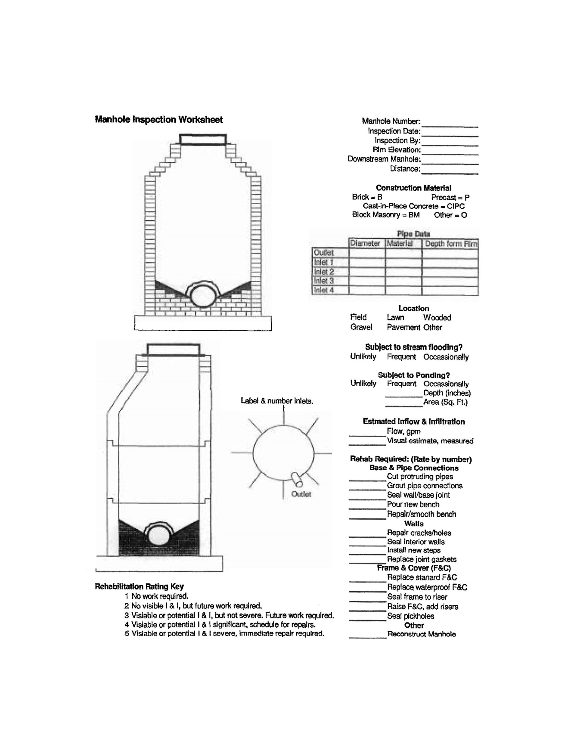
Appendix 9.4: Manhole Inspection Comments

Appendix 9.5: Lift Station Inspection Worksheet

Lift Station Inspection
Lift Station Location/ID: ___________________________ Month: ___________

Required Preventative Maintenance

1. Daily -check general operations and hour meter readings
2. Weekly -check the amperage and volts
3. Monthly -check the level controls
4. Semi-annually -drain the lift station and clean
5. Annually -while drained perform a thorough inspection of the lift station

Date | Operate  HOA | Pump #1 Hours | Pump#1 Hours/Day | Pump # 2 Hours | Pump #2 Hours/Day | Pump # 1 Amps and Volts | Pump # 2 Amps and Volts | Level Controls | Initials
1
2
3
4
5
6
7
8
9
10
11
12
13
14
15
16
17
18
19
20
21
22
23
24
25
26
27
28
29
30
31

Appendix 9.6: Sewer Line Maintenance Repair Report
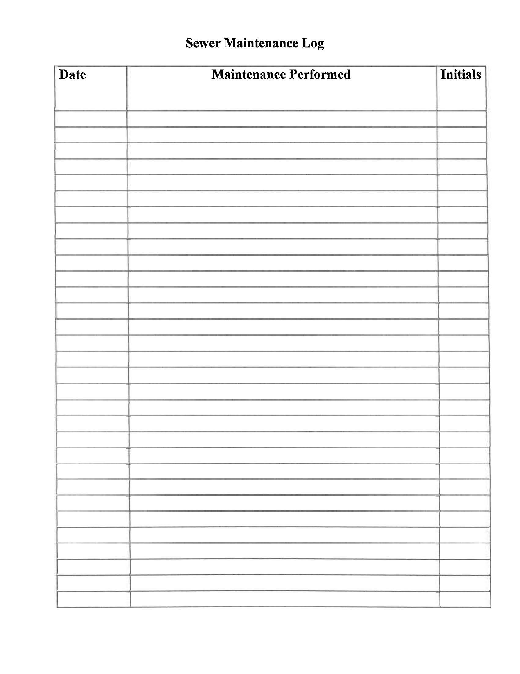
Appendix 9.7: Sewer Complaint Report
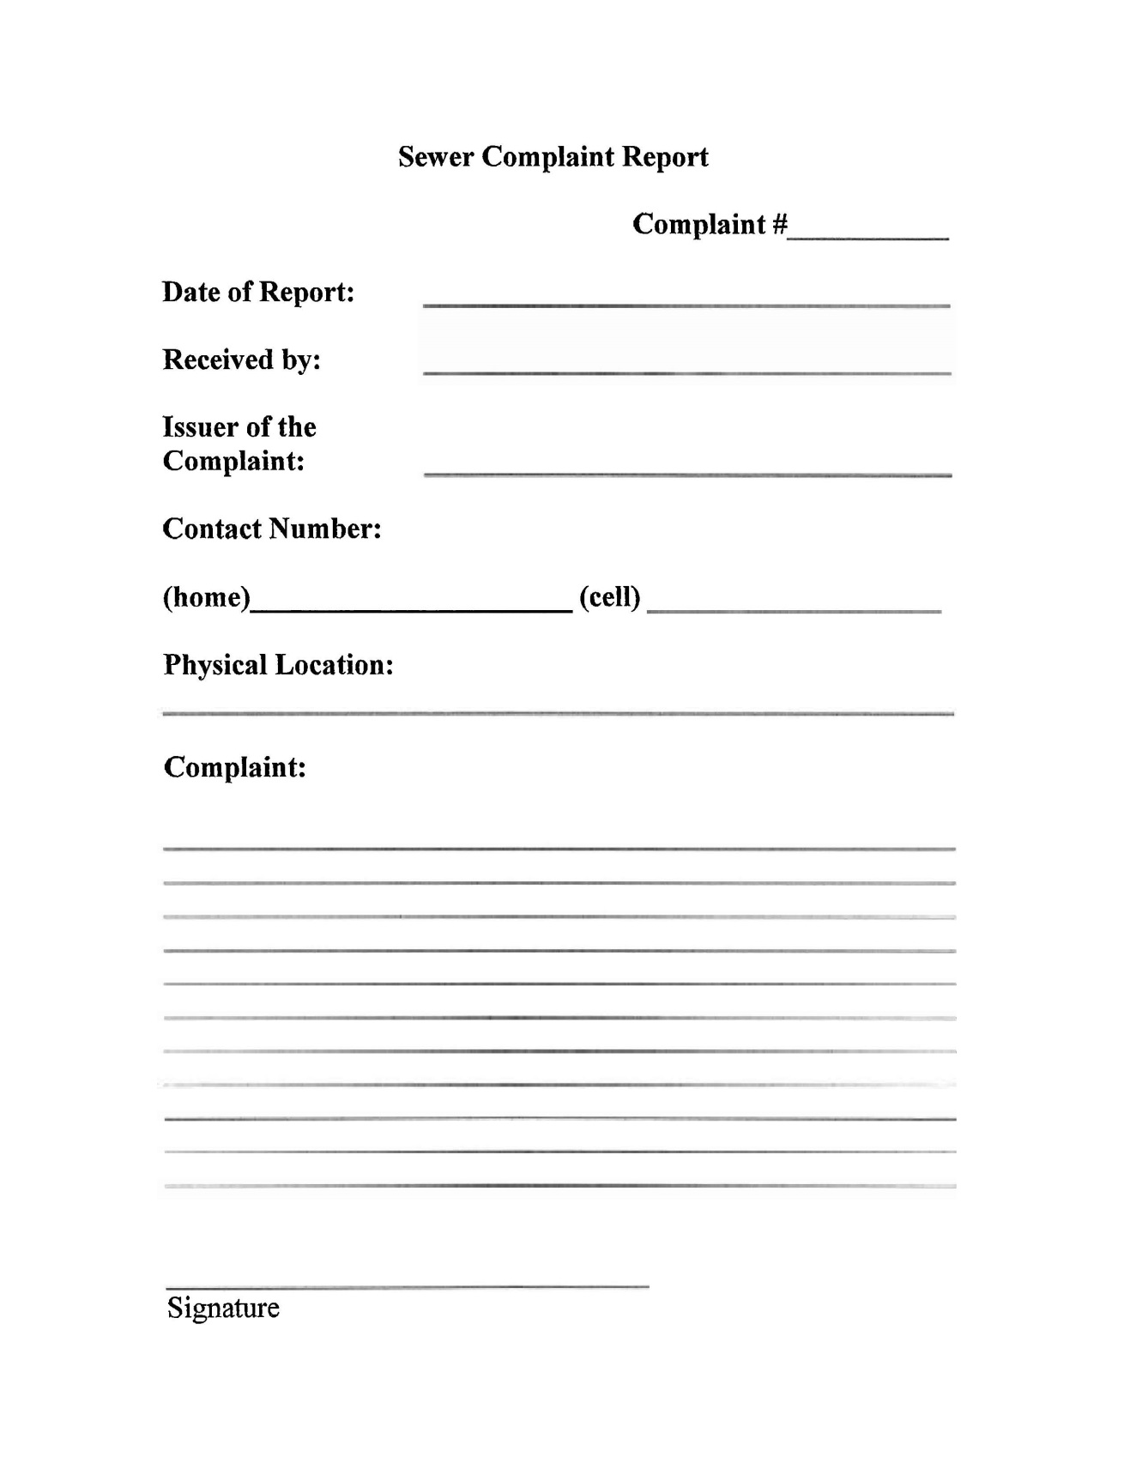
Appendix 9.8: Sewer Response Report
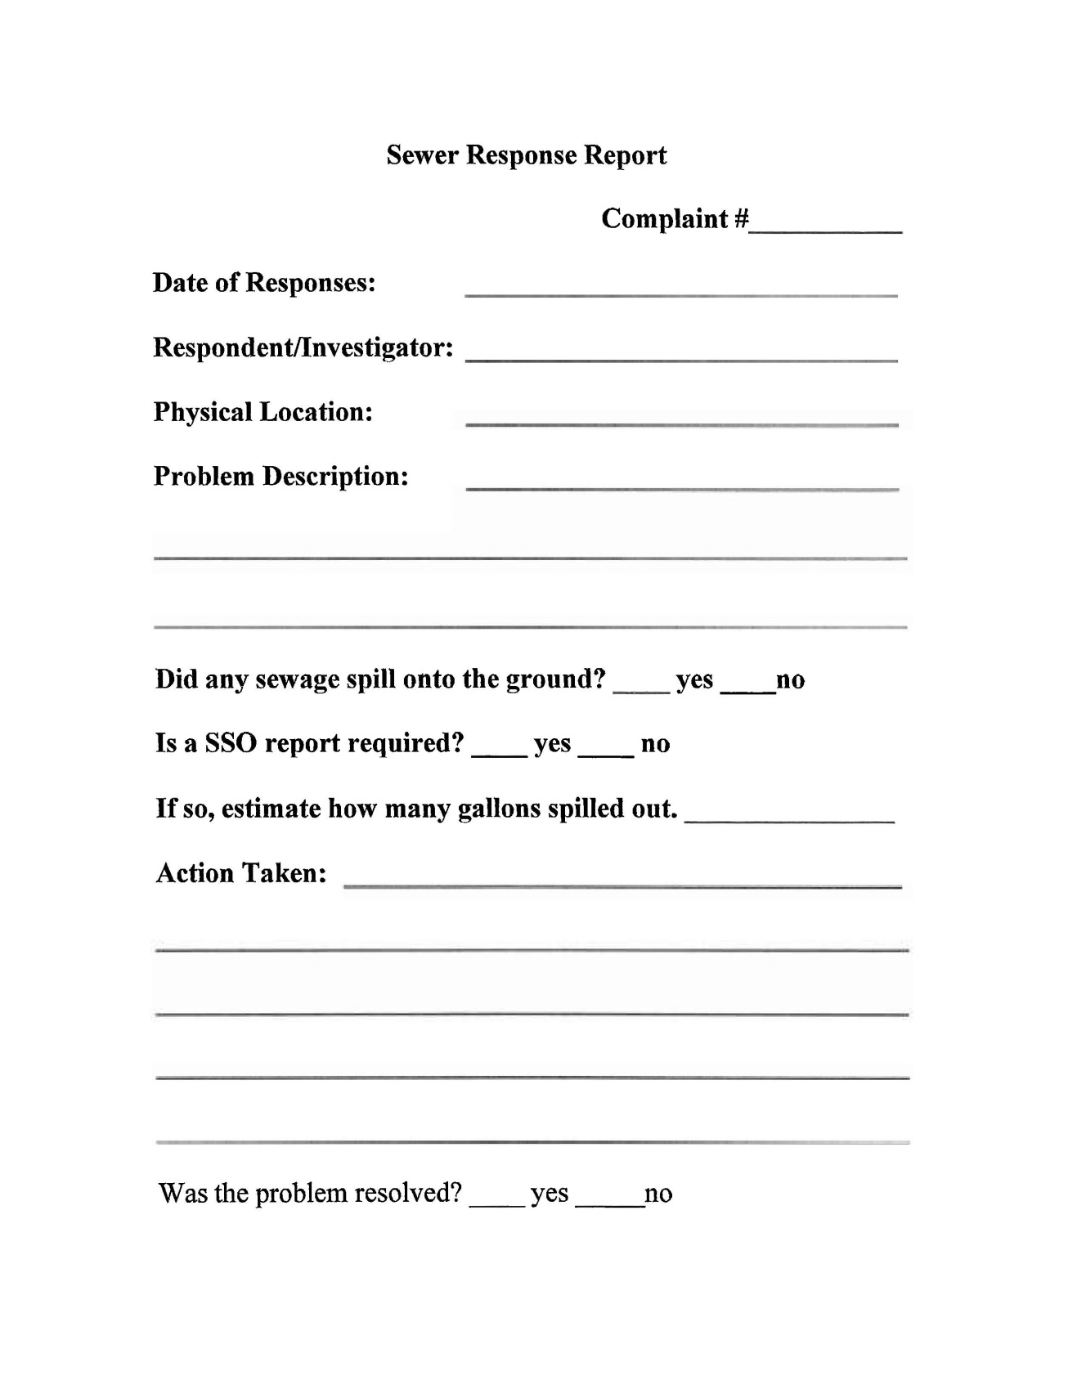

Appendix 9.9: Tracking Form for SSO/ Bypasses
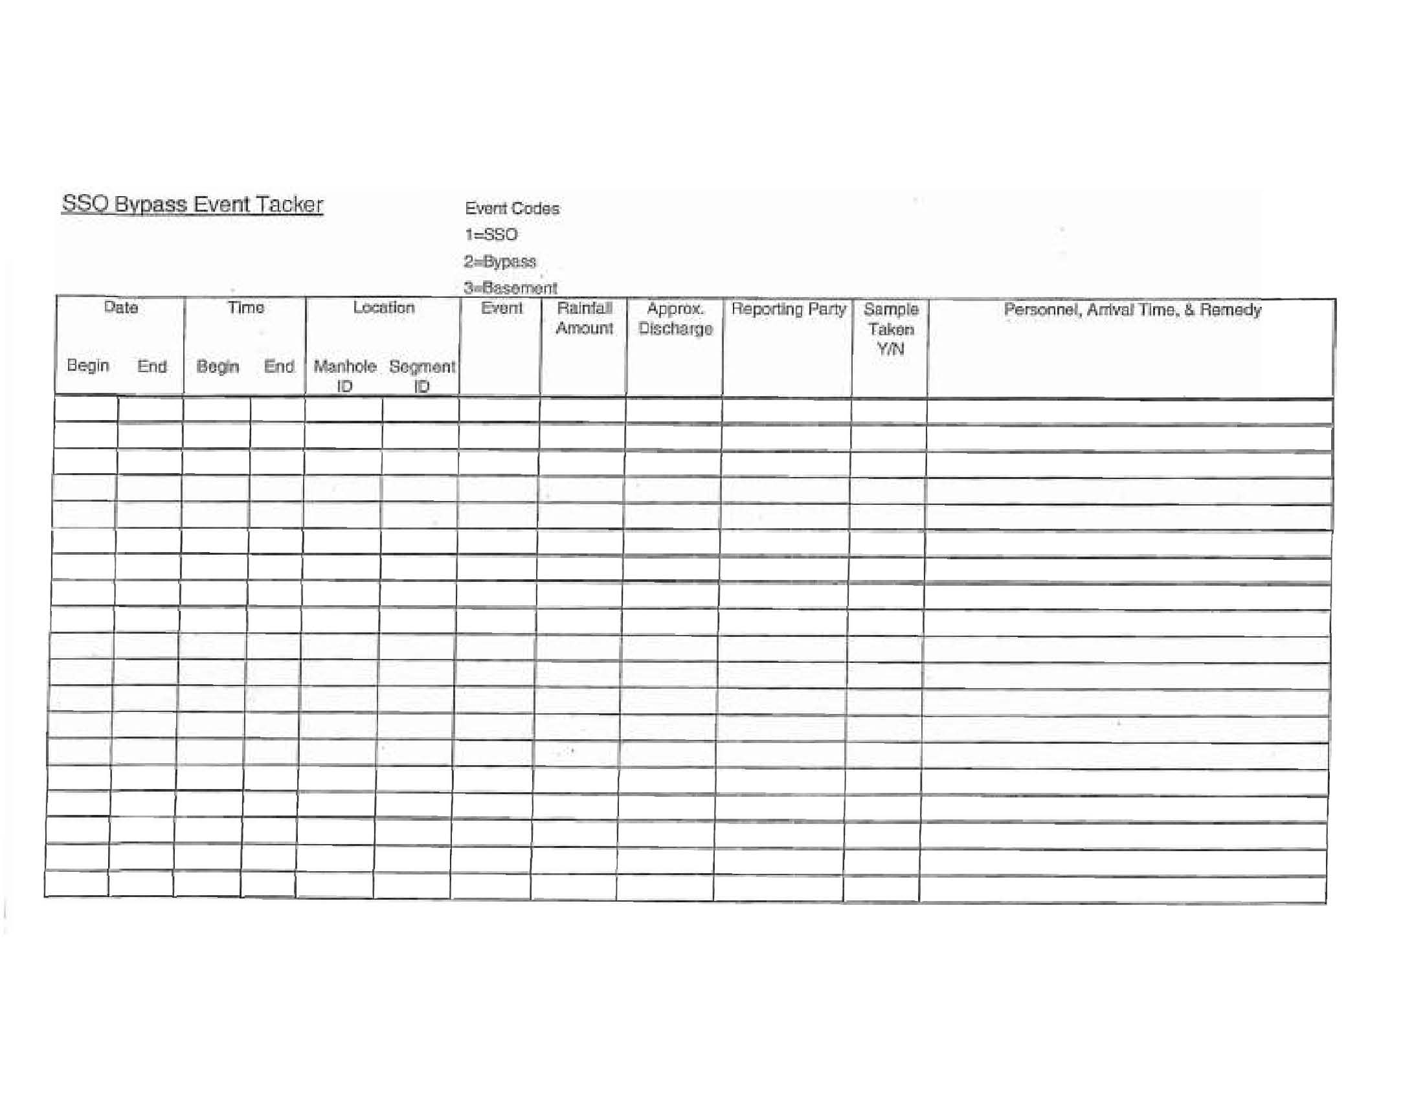
Appendix 9.10: Self-Reporting Form for Wastewater SSOs/Bypasses
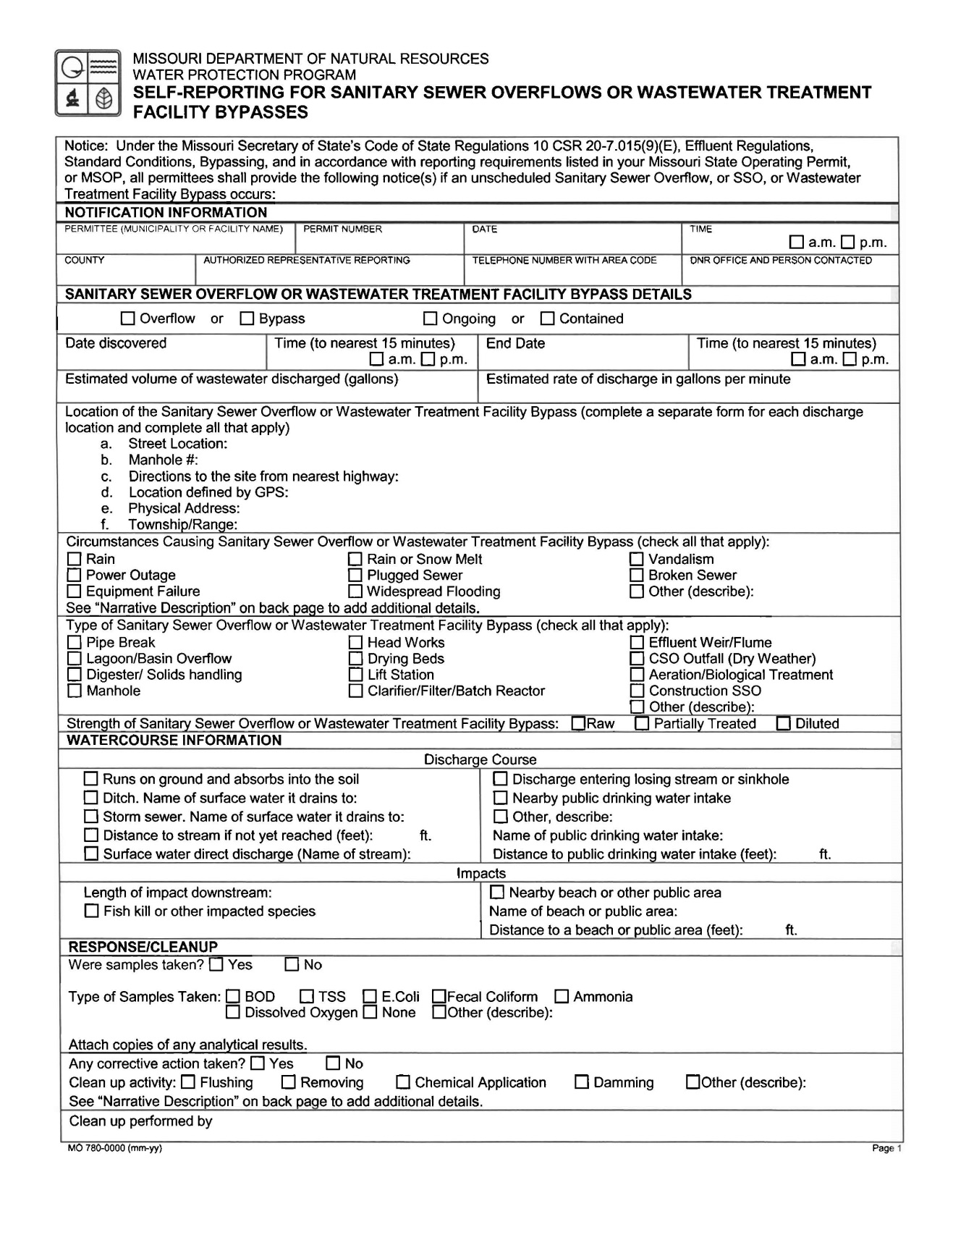

Appendix 9.10: Self-Reporting Form for Wastewater SSOs/Bypasses Continued…
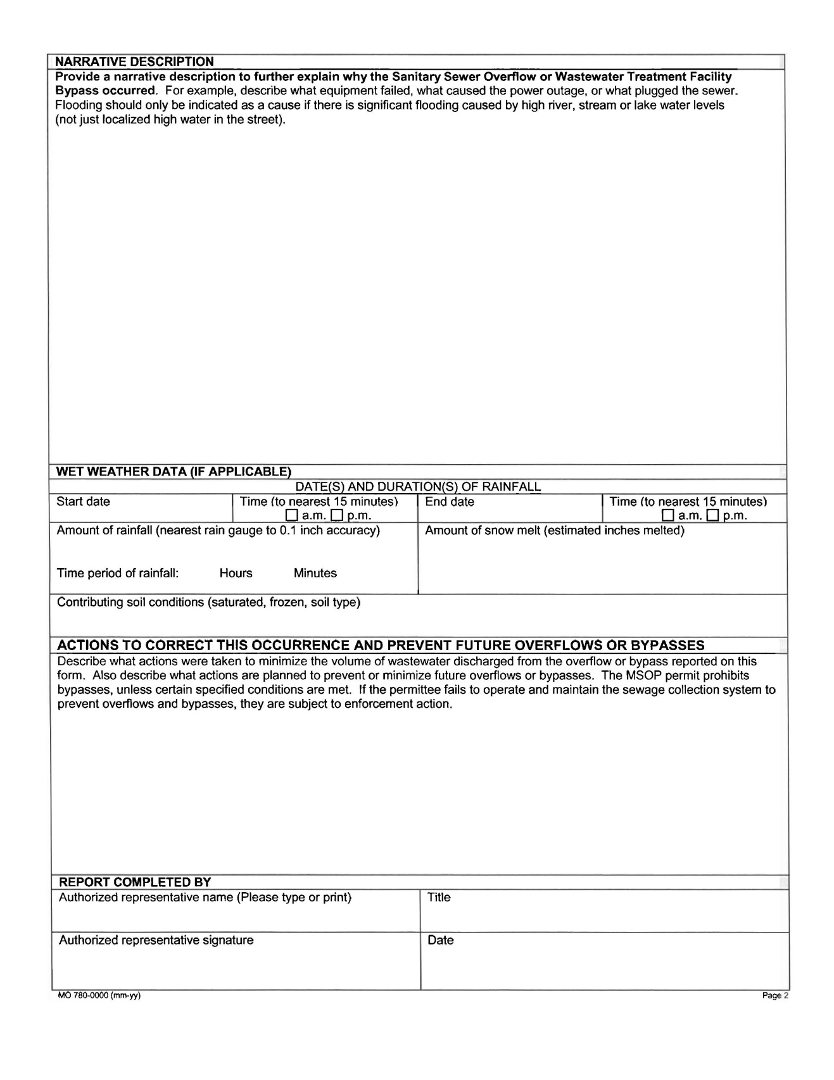
Appendix 9.11: Capital Improvement Budget

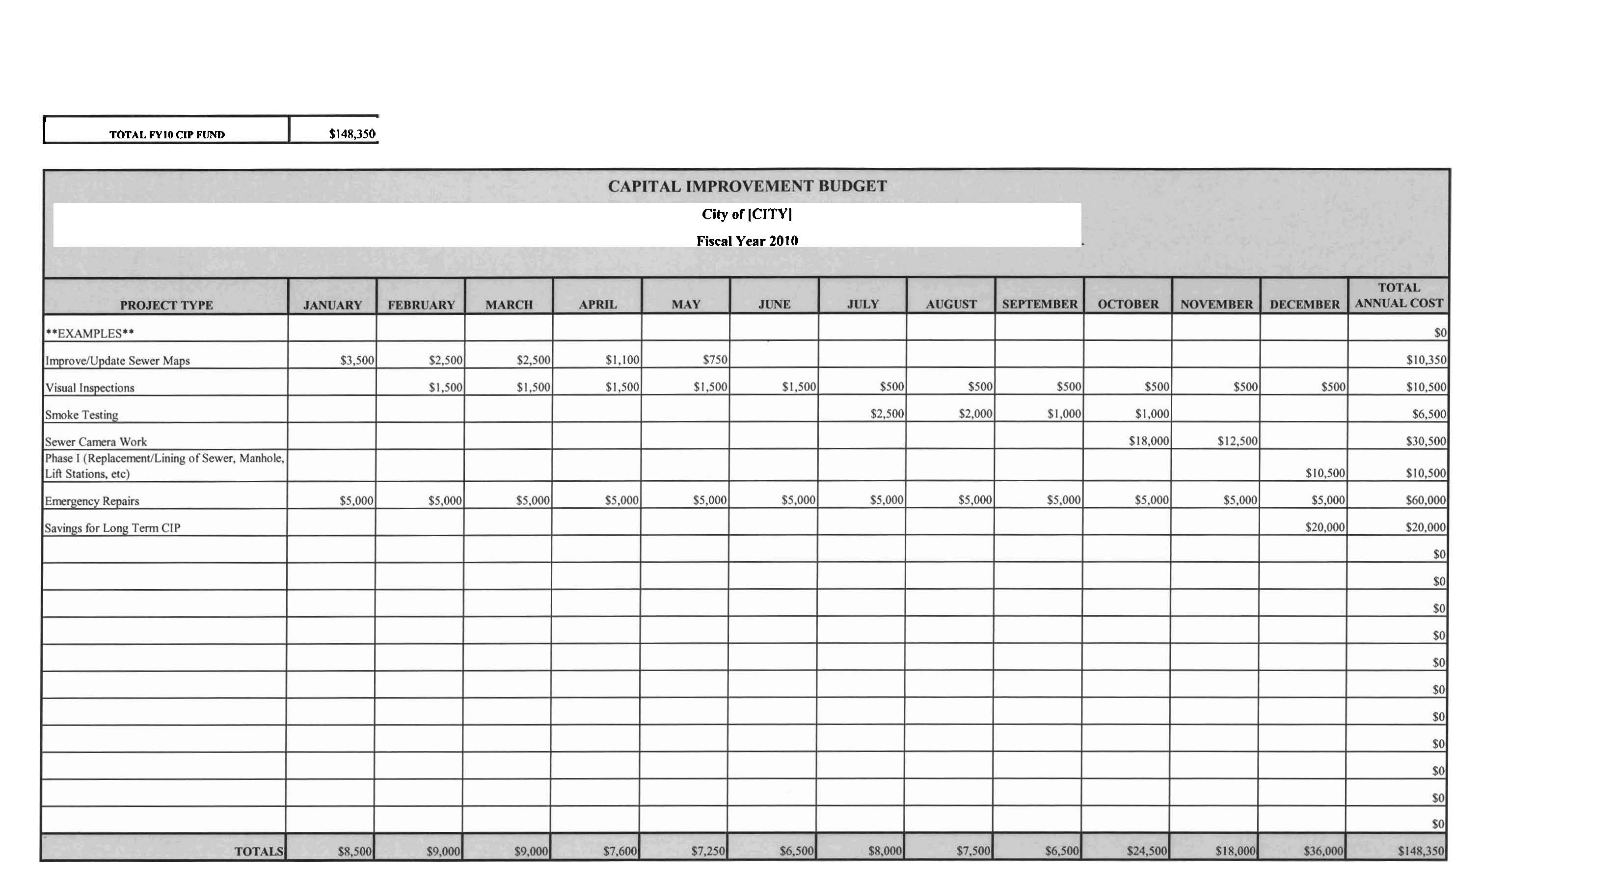
Appendix 9.12: Capital Improvement Projects

